**Title Of Project**

**Online Pizza Order System**

**Table of Contents**

**Title Page Number**

1. **Certificate**
2. **Acknowledgement**
3. **Introduction to Online Blood Pizza Order System**

* **Project Overview**
* **Project Description**
* **Objectives**

1. **Project Code and Screen Layout**

***Project Overview***

*The project entitled “Online Pizza Order System” is done to make the manual process easier by making it a computerised system for registering and maintaining details of the donor or other people.*

*The project can be used to store useful data online , and to automate the storing and retrieval of data. It is very helpful in maintaining the record of the user like name , address , contact information, email address and other information.*

*The entered data can also be updated or deleted as per the requirement of the user.*

*The user need to signin and update the information of their choice. All details are processed very easily.*

***Project Description***

*The project named “Online Pizza Order System” is done to make the manual process easier by making it a computerised system for maintaining all the records.*

*The user sign up in the directory and then log in their account all store information and all the data is stored in the database. This system is very simple and efficient.*

*Online Pizza Order System proposed to be an automate database management and transaction. This stores username, address, contact no., email address , resident addres. It also provide facility of advanced search. It provides data storing with graphical user interface.*

*The following are involved in this project: User Login, Order Pizza, Home Page, New Registration etc.*

***Objectives***

*The main objective of this project are summarised below:*

* *To design and develop a user friendly efficient computerised Blood Donation System.*
* *An accurate system without data redundancy.*
* *Secured data storage for authority end.*
* *To provide a graphical user interface.*
* *To store large amount of data.*
* *To develop a flexible system which can update and delete the various entered records.*
* *Computerisation that can be helpful as means of saving time and money.*

***Data Flow Diagram***

*A data flow diagram is the best and easiest tool to represent the flow of the data in the project. It is otherwise known as bubble chart. It has the purpose of clarifying system requirements and identifying major transformation that will become programs in the system design. It is the major starting point in the design phase that functionally decomposes the requirement specification down to the lowest level of detail.*

*It has four major symbol :*

*A square represents source or destination*

*A arrow represents the data flow*

*A circle represents the process*

*An open rectangle represents a data store.*

Home Page

New Registration

Order Pizza

Payments

PhonePe / BHIM UPI Payments

NET Banking Payments

Creadit Card / Debit Card Payments

***Project Code &***

***Screen Layouts***

***Database Design :***

*Database name - Database*

*Table used - LoginTable, Order Table*

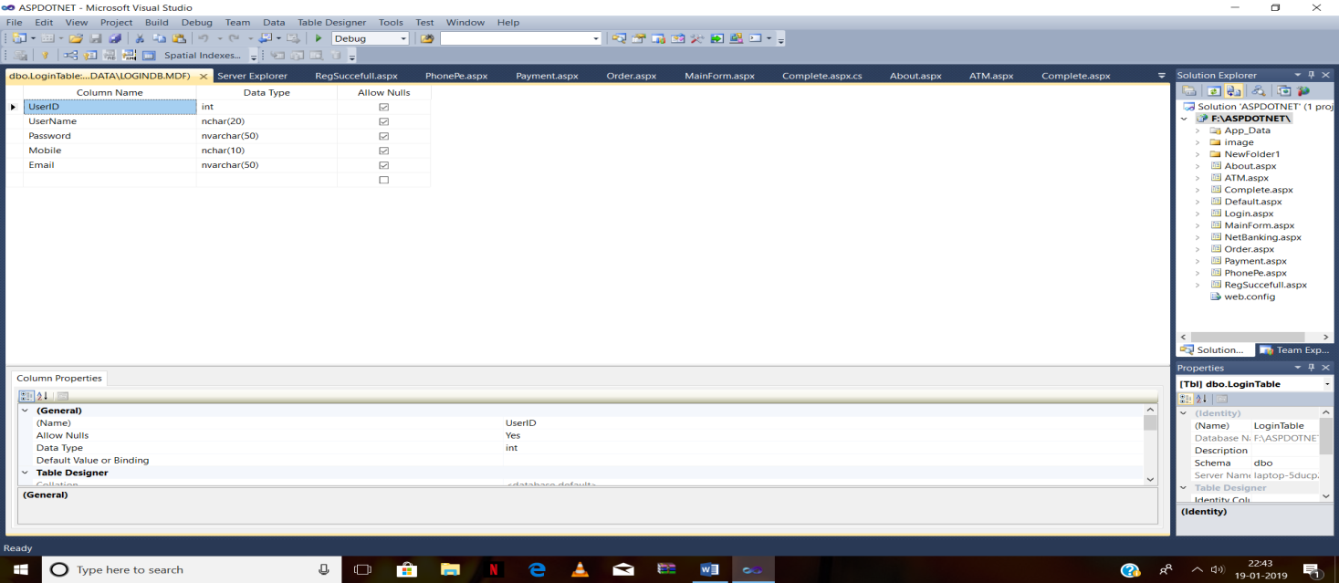

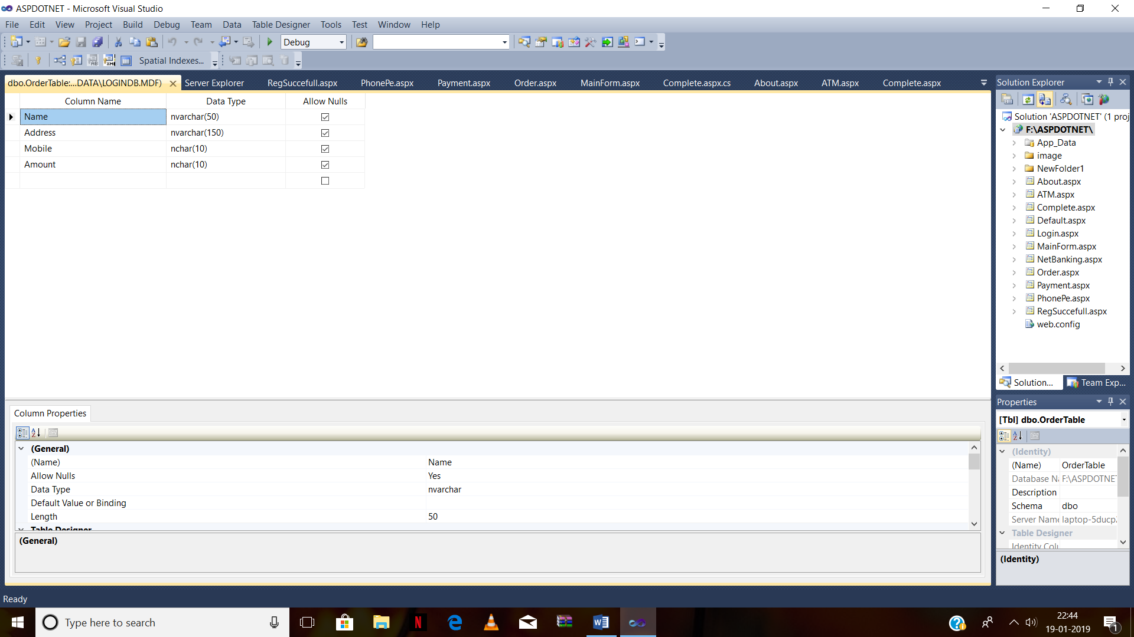

***Home Page(.aspx)***

**Design Soure**

<%@ Page Language="C#" AutoEventWireup="true" CodeFile="MainForm.aspx.cs" Inherits="MainForm" %>

<!DOCTYPE html PUBLIC "-//W3C//DTD XHTML 1.0 Transitional//EN" "http://www.w3.org/TR/xhtml1/DTD/xhtml1-transitional.dtd">

<html xmlns="http://www.w3.org/1999/xhtml">

<head runat="server">

<title></title>

<style type="text/css">

.style1

{

font-size: xx-large;

font-weight: 700;

}

.style8

{

width: 100%;

height: 373px;

}

.style9

{

width: 550px;

}

.style10

{

color: #FF0000;

}

.style11

{

color: #0000FF;

}

.style12

{

color: #00FF00;

}

.style13

{

font-size: xx-large;

color: #FFFFFF;

}

</style>

</head>

<body style="font-family: Algerian">

<form id="form1" runat="server">

<div style="background-color: #FF0000; width: 1849px; height: 135px;">

<br />

<strong><span class="style13”>

Happy Pizza&nbsp;

<br />

<asp:Button ID="Button1" runat="server" BackColor="#00CCFF" Height="34px"

onclick="Button1_Click" Text="Home" Width="183px" />

&nbsp;

<asp:Button ID="Button2" runat="server" BackColor="#00CCFF" Height="34px"

onclick="Button2_Click" Text="Login" Width="183px" />

&nbsp;

<asp:Button ID="Button3" runat="server" BackColor="#00CCFF" Height="34px"

onclick="Button3_Click" Text="New Registration" Width="183px" />

&nbsp;

<asp:Button ID="Button4" runat="server" BackColor="#00CCFF" Height="34px"

onclick="Button4_Click" Text="About us" Width="183px" />

</span></strong>

</div>

<p>

<span class="style1">

<asp:Image ID="Image1" runat="server" Height="194px"

ImageUrl="~/NewFolder1/398148-full-size-pizza-wallpaper-1920x1200-hd-1080p.jpg"

style="margin-top: 0px" Width="1550px" />

</span>

</p>

<table class="style8">

<tr>

<td class="style9">

<asp:Image ID="Image3" runat="server" Height="303px"

ImageUrl="~/image/Fast_food_Pizza_Pepper_Tomatoes_Olive_White_515874_2560x1440.jpg"

Width="491px" style="margin-right: 42px" />

<span class="style10">LOVE YOUR Choice</span></td>

<td style="font-family: Arial">

<strong><span class="style11">Welcome to Happy Pizza .We searve Love . We

provide 24 X 7 hours delivery .

<br />

Happy Pizza is a family that serve you happy.

Since 2000 we are running this </span>

<br class="style11" />

<span class="style11">family bussiness. Proudely serving our neighbourhood with

authenetic,fresh,<br />

&nbsp;hot and delicious food.</span><br class="style11" />

<span class="style11">

We called it Fantastic Pizza because we like our customers to

<br />

havea Fantastic One !!</span></strong></td>

</tr>

<tr>

<td class="style9">

<asp:Image ID="Image4" runat="server" Height="354px"

ImageUrl="~/image/pizzagirl.jpg" Width="578px" />

</td>

<td style="font-family: Arial">

<ul>

<li class="style12">We provide very fast delivery.</li>

<li class="style12">24 X 7 hours service provide.</li>

<li class="style12">We also provide COD fasility.</li>

<li class="style12">If your item is not delivered within 30 minute then we give your

pizza free.</li>

</ul>

<p>

&nbsp;</p>

</td>

</tr>

</table>

</form>

</body>

</html>

**Source Code**

using System;

using System.Collections.Generic;

using System.Linq;

using System.Web;

using System.Web.UI;

using System.Web.UI.WebControls;

public partial class MainForm : System.Web.UI.Page

{

protected void Button1_Click(object sender, EventArgs e)

{

Response.Redirect("MainForm.aspx");

}

protected void Button2_Click(object sender, EventArgs e)

{

Response.Redirect("Login.aspx");

}

protected void Button3_Click(object sender, EventArgs e)

{

Response.Redirect("Default.aspx");

}

protected void Button4_Click(object sender, EventArgs e)

{

Response.Redirect("About.aspx");

}

}

LoginPage***(.aspx)***

**Design Code**

<%@ Page Language="C#" AutoEventWireup="true" CodeFile="Login.aspx.cs" Inherits="Login" MasterPageFile="" %>

<!DOCTYPE html PUBLIC "-//W3C//DTD XHTML 1.0 Transitional//EN" "http://www.w3.org/TR/xhtml1/DTD/xhtml1-transitional.dtd">

<html xmlns="http://www.w3.org/1999/xhtml">

<head runat="server">

<title></title>

<style type="text/css">

#Reset1

{

width: 176px;

height: 41px;

}

#Password1

{

font-size: large;

font-family: Arial;

}

#Password2

{

font-size: large;

font-family: Arial;

width: 233px;

height: 38px;

}

.style1

{

font-size: xx-large;

text-decoration: underline;

font-family: Algerian;

color: #FFFFFF;

}

.style6

{

color: #FFFFFF;

}

.style7

{

width: 116%;

}

.style8

{

height: 365px;

width: 400px;

}

.style13

{

width: 400px;

}

.style16

{

width: 400px;

height: 146px;

}

.style18

{

color: #FF0000;

}

.style23

{

color: #FF0000;

width: 315px;

}

.style24

{

width: 315px;

}

.style25

{

height: 365px;

width: 315px;

}

.style26

{

width: 315px;

height: 146px;

}

.style28

{

height: 365px;

width: 908px;

}

.style29

{

width: 908px;

height: 146px;

}

.style30

{

width: 908px;

}

.style4

{

height: 154px;

}

.style5

{

color: #FFFFFF;

}

</style>

<script language="javascript" type="text/javascript">

// <![CDATA[

function Password2_onclick() {

}

// ]]>

</script>

</head>

<body bgcolor="#ffffcc" style="height: 690px; width: 1606px;">

<form id="form1" runat="server">

<div align="left"

style="background-color: #FF0000; width: 1860px; height: 133px;">

<span class="style6">&nbsp;</span>&nbsp;&nbsp;&nbsp;&nbsp;&nbsp;&nbsp;&nbsp;

<br />

<span class="style1"><strong>Happy

Pizza</strong></span><br />

<span class="style4"><span class="style5">&nbsp;<strong><span class="style13"><asp:Button ID="Button6" runat="server"

BackColor="#00CCFF" Height="34px"

onclick="Button6_Click" Text="Home" Width="183px" />

&nbsp;

<asp:Button ID="Button3" runat="server" BackColor="#00CCFF" Height="34px"

onclick="Button3_Click" Text="Login" Width="183px" Enabled="False" />

&nbsp;

<asp:Button ID="Button4" runat="server" BackColor="#00CCFF" Height="34px"

onclick="Button4_Click" Text="New Registration" Width="183px" />

&nbsp;

<asp:Button ID="Button5" runat="server" BackColor="#00CCFF" Height="34px"

onclick="Button5_Click" Text="About us" Width="183px" />

</span></strong>

</span></span>

<br />

</div>

<table class="style7">

<tr>

<td class="style24">

&nbsp;</td>

<td class="style30">

&nbsp;</td>

<td class="style13">

&nbsp;</td>

</tr>

<tr>

<td class="style25">

<asp:Image ID="Image1" runat="server" Height="373px"

ImageUrl="~/image/pizza_man1.png" Width="315px" />

</td>

<td class="style28">

<p align="center" >

<asp:Label ID="lblErrorMsg" runat="server" ForeColor="Blue"

Text="Wrong UserName or Password . Please check." BorderStyle="Dotted"

style="text-align: center" Width="446px"></asp:Label>

</p>

<p align="center">

<asp:Label ID="Label1" runat="server" BackColor="#00CCFF" BorderColor="Lime"

BorderStyle="Double" ForeColor="Red" Height="55px"

style="font-weight: 700; font-size: xx-large; font-family: Arial, Helvetica, sans-serif"

Text="User Login" Width="429px"></asp:Label>

</p>

<p align="center">

<asp:Label ID="Label2" runat="server" AssociatedControlID="Label1"

BorderStyle="None" Height="28px"

style="font-size: large; font-family: Algerian" Text="UserName"></asp:Label>

<asp:TextBox ID="txtUser" runat="server" Height="37px"

style="font-size: large; font-family: Arial" Width="232px"

ontextchanged="TextBox1_TextChanged"></asp:TextBox>

</p>

<p align="center">

&nbsp;&nbsp;&nbsp;&nbsp;&nbsp;&nbsp;

<asp:Label ID="Label3" runat="server" AssociatedControlID="Label1"

BorderStyle="None" Height="28px"

style="font-size: large; font-family: Algerian" Text="Password"></asp:Label>

<asp:TextBox

ID="txtPass" runat="server" Height="37px"

style="font-size: large; font-family: Arial" Width="232px"

ontextchanged="TextBox1_TextChanged" TextMode="Password"

CausesValidation="True"></asp:TextBox>

</p>

<p align="center">

</p>

<p align="center">

&nbsp;<asp:Button ID="Button1" runat="server" BackColor="#33CCCC" Height="38px"

Text="Login" Width="185px" onclick="Button1_Click" />

<asp:Button ID="Button2" runat="server" BackColor="#33CCCC" Height="38px"

Text="Clear" Width="185px" />

</p>

<p align="center">

&nbsp;<asp:Button ID="btnRegistration" runat="server" BackColor="#33CCCC" Height="38px"

Text="New User Registration" Width="427px" onclick="btnRegistration_Click"

ForeColor="Red" />

</p>

</td>

<td class="style8">

&nbsp;</td>

</tr>

<tr>

<td class="style26">

<asp:Image ID="Image3" runat="server" Height="117px"

ImageUrl="~/image/398148-full-size-pizza-wallpaper-1920x1200-hd-1080p.jpg"

Width="246px" />

</td>

<td class="style29">

&nbsp;<asp:Image ID="Image4" runat="server" Height="117px"

ImageUrl="~/image/pizza-2.jpg.imgo.jpg" Width="246px" />

<asp:Image ID="Image5" runat="server" Height="117px"

ImageUrl="~/image/pizza-2.jpg.imgo.jpg" Width="246px" />

</td>

<td class="style16">

&nbsp;</td>

</tr>

<tr>

<td class="style23">

&nbsp;&nbsp;&nbsp;&nbsp;&nbsp;&nbsp;&nbsp;&nbsp;&nbsp; Vegiterian Pizza</td>

<td class="style30">

<span class="style18">Italian Pizza Non - Veg Pizza</span></td>

<td class="style13">

&nbsp;</td>

</tr>

</table>

</form>

</body>

</html>

**Source Code**

using System;

using System.Collections.Generic;

using System.Linq;

using System.Web;

using System.Web.UI;

using System.Web.UI.WebControls;

using System.Data.SqlClient;

using System.Data;

public partial class Login : System.Web.UI.Page

{

SqlConnection conn = new SqlConnection(@"Data Source=.\SQLEXPRESS;AttachDbFilename=F:\ASPDOTNET\App_Data\LoginDB.mdf;Integrated Security=True;User Instance=True");

protected void Page_Load(object sender, EventArgs e)

{

lblErrorMsg.Visible = false;

}

protected void Button1_Click(object sender, EventArgs e)

{

conn.Open();

SqlCommand cmd = conn.CreateCommand();

cmd.CommandType = CommandType.Text;

cmd.CommandText = "select * from LoginTable where UserName='" + txtUser.Text + "' and Password='" + txtPass.Text + "'" ;

cmd.ExecuteNonQuery();

SqlDataReader reader = cmd.ExecuteReader();

int count = 0;

while (reader.Read())

{

count = count + 1;

}

if (count == 1)

{

Response.Redirect("Order.aspx");

}

else

{

lblErrorMsg.Visible=true ;

}

conn.Close();

}

protected void btnRegistration_Click(object sender, EventArgs e)

{

Response.Redirect("Default.aspx");

}

protected void Button6_Click(object sender, EventArgs e)

{

Response.Redirect("MainForm.aspx");

}

protected void Button3_Click(object sender, EventArgs e)

{

Response.Redirect("Login.aspx");

}

protected void Button4_Click(object sender, EventArgs e)

{

Response.Redirect("Default.aspx");

}

protected void Button5_Click(object sender, EventArgs e)

{

Response.Redirect("About.aspx");

}

}

***New Registration***

using System;

using System.Collections.Generic;

using System.Linq;

using System.Web;

using System.Web.UI;

using System.Web.UI.WebControls;

using System.Data.SqlClient;

using System.Data;

public partial class _Default : System.Web.UI.Page

{

SqlConnection conn = new SqlConnection(@"Data Source=.\SQLEXPRESS;AttachDbFilename=F:\ASPDOTNET\App_Data\LoginDB.mdf;Integrated Security=True;User Instance=True");

protected void Page_Load(object sender, EventArgs e)

{

}

protected void btnCancel_Click(object sender, EventArgs e)

{

Response.Redirect("Login.aspx");

}

protected void Button2_Click(object sender, EventArgs e)

{

if (txtCPass.Text == "" || txtEmail.Text == "" || txtID.Text == "" || txtMobile.Text == "" || txtPass.Text == "" || txtUser.Text == "")

{

Page.ClientScript.RegisterStartupScript(this.GetType(), "script", "<script>alert(' Please Fill all the field completely');</script>");

}

else

{

if (txtPass.Text != txtCPass.Text)

{

CompareValidator1.Visible = true;

}

else

{

conn.Open();

SqlCommand cmd = conn.CreateCommand();

cmd.CommandType = CommandType.Text;

cmd.CommandText = " INSERT INTO LoginTable VALUES(" + txtID.Text + ",'" + txtUser.Text + "', '" + txtPass.Text + "', " + txtMobile.Text + ", '" + txtEmail.Text + "')";

cmd.ExecuteNonQuery();

conn.Close();

Response.Redirect("RegSuccefull.aspx");

clear();

}

}

}

protected void clear()

{

txtUser.Text = "";

txtMobile.Text = "";

txtEmail.Text = "";

txtPass.Text = "";

txtCPass.Text = "";

}

protected void Button6_Click(object sender, EventArgs e)

{

Response.Redirect("MainForm.aspx");

}

protected void Button3_Click(object sender, EventArgs e)

{

Response.Redirect("Login.aspx");

}

protected void Button4_Click(object sender, EventArgs e)

{

Response.Redirect("Default.aspx");

}

protected void Button5_Click(object sender, EventArgs e)

{

Response.Redirect("About.aspx");

}

}

***Order Pizza***

using System;

using System.Collections.Generic;

using System.Linq;

using System.Web;

using System.Web.UI;

using System.Web.UI.WebControls;

using System.Data.SqlClient;

using System.Data;

public partial class Order : System.Web.UI.Page

{

SqlConnection conn = new SqlConnection(@"Data Source=.\SQLEXPRESS;AttachDbFilename=F:\ASPDOTNET\App_Data\LoginDB.mdf;Integrated Security=True;User Instance=True");

static int amount = 0;

protected void Button4_Click(object sender, EventArgs e)

{

Response.Redirect("Default.aspx");

}

protected void Bt7_Click(object sender, EventArgs e)

{

int a , b, c, d, f, gh ;

a = (Convert.ToInt32(TB1.Text))*435;

b = (Convert.ToInt32(TB2.Text))* 340;

c = (Convert.ToInt32(TB7.Text))* 285;

d = (Convert.ToInt32(TB4.Text))* 315;

f = (Convert.ToInt32(TB5.Text))* 315;

gh = (Convert.ToInt32(TB6.Text))* 355;

amount =amount + a + b + c + d + f + gh;

if (CheckBox2.Checked == true)

{

amount = amount + 105;

}

TBTotal.Text = Convert.ToString(amount);

}

protected void btnOrder_Click(object sender, EventArgs e)

{

Session["Name"] = txtName.Text;

Session["Add"] = txtAddress.Text;

Session["Phone"] = txtMobile.Text;

Session["Bill"] = TBTotal.Text;

if (txtName.Text == "" || txtAddress.Text == "" || txtMobile.Text == "" || TBTotal.Text == "")

{

Page.ClientScript.RegisterStartupScript(this.GetType(), "script", "<script>alert(' Please Fill all the field completely');</script>");

}

else

{

conn.Open();

SqlCommand cmd = conn.CreateCommand();

cmd.CommandType = CommandType.Text;

cmd.CommandText = " INSERT INTO OrderTable VALUES('" + txtName.Text + "','" + txtAddress.Text + "', '" + txtMobile.Text + "', '" + TBTotal.Text + "')";

cmd.ExecuteNonQuery();

conn.Close();

Response.Redirect("Payment.aspx");

}

}

protected void Button2_Click(object sender, EventArgs e)

{

Response.Redirect("MainForm.aspx");

}

protected void Button3_Click(object sender, EventArgs e)

{

Response.Redirect("Login.aspx");

}

protected void Button5_Click(object sender, EventArgs e)

{

Response.Redirect("About.aspx");

}

}

***Payments (.aspx)***

**Design Code**

<%@ Page Language="C#" AutoEventWireup="true" CodeFile="Payment.aspx.cs" Inherits="Payment" %>

<!DOCTYPE html PUBLIC "-//W3C//DTD XHTML 1.0 Transitional//EN" "http://www.w3.org/TR/xhtml1/DTD/xhtml1-transitional.dtd">

<html xmlns="http://www.w3.org/1999/xhtml">

<head runat="server">

<title></title>

<style type="text/css">

.style1

{

font-size: xx-large;

font-family: Algerian;

color: #FFFFFF;

}

#form1

{

height: 126px;

width: 1580px;

}

.style6

{

width: 76%;

height: 568px;

}

.style10

{

width: 631px;

height: 363px;

}

.style11

{

height: 363px;

}

.style12

{

font-size: x-large;

text-decoration: underline;

}

.style13

{

font-size: xx-large;

color: #FFFFFF;

}

</style>

</head>

<body>

<form id="form1" runat="server">

<div style="background-color: #FF0000; width: 1637px;">

<br />

<strong>Happy Pizza</strong></span><br />

<strong><span class="style13">

<asp:Button ID="Button2" runat="server" BackColor="#00CCFF" Height="34px"

onclick="Button2_Click" Text="Home" Width="183px" />

&nbsp;

<asp:Button ID="Button3" runat="server" BackColor="#00CCFF" Height="34px"

onclick="Button3_Click" Text="Login" Width="183px" Enabled="False" />

&nbsp;

<asp:Button ID="Button4" runat="server" BackColor="#00CCFF" Height="34px"

onclick="Button4_Click" Text="New Registration" Width="183px"

Enabled="False" />

&nbsp;

<asp:Button ID="Button5" runat="server" BackColor="#00CCFF" Height="34px"

onclick="Button5_Click" Text="About us" Width="183px" />

</span></strong>

<br />

<br />

</div>

&nbsp;

<table class="style6">

<tr>

<td class="style10">

<asp:Image ID="Image1" runat="server" Height="413px"

ImageUrl="~/image/32427317-cartoon-character-of-computer-mouse-with-pizza.jpg"

Width="554px" />

</td>

<td class="style11">

<strong><span class="style12">Payments

nbsp;</span></strong><br />

<br />

<br />

<br />

&nbsp;&nbsp;&nbsp;&nbsp;&nbsp;&nbsp;

<asp:RadioButton runat="server" ForeColor="#3333CC"

Text=" PhonePe / BHIM UPI" style="font-size: large" ID="radio1"

GroupName="Pay" oncheckedchanged="radio1_CheckedChanged" />

<br />

<br />

&nbsp;&nbsp;&nbsp;&nbsp;&nbsp;&nbsp;

<asp:RadioButton ID="RadioButton1" runat="server" ForeColor="#3333CC"

Text=" Net Banking" style="font-size: large" GroupName="Pay"

oncheckedchanged="RadioButton1_CheckedChanged" />

<br />

<br />

&nbsp;&nbsp;&nbsp;&nbsp;&nbsp;&nbsp;

<asp:RadioButton ID="RadioButton2" runat="server" ForeColor="#3333CC"

Text=" Creadit / Debit / ATM Card" style="font-size: large"

GroupName="Pay" oncheckedchanged="RadioButton2_CheckedChanged" />

<br />

<br />

&nbsp;&nbsp;&nbsp;&nbsp;&nbsp;&nbsp;

<asp:RadioButton ID="RadioButton3" runat="server" ForeColor="#3333CC"

Text=" Cash On Delivery" style="font-size: large" GroupName="Pay"

oncheckedchanged="RadioButton3_CheckedChanged" />

<br />

<br />

<br />

<br />

&nbsp;&nbsp;&nbsp;&nbsp;&nbsp;

<asp:Button ID="btnContinue" runat="server" Height="37px"

style="font-size: large; font-weight: 700" Text="Continue" Width="170px"

onclick="btnContinue_Click" />

<asp:Button ID="btnCancel" runat="server" Height="37px"

style="font-size: large; font-weight: 700" Text="Cancel" Width="170px" />

</td>

</tr>

</table>

</form>

</body>

</html>

**Source Code**

using System;

using System.Collections.Generic;

using System.Linq;

using System.Web;

using System.Web.UI;

using System.Web.UI.WebControls;

public partial class Payment : System.Web.UI.Page

{

protected void Page_Load(object sender, EventArgs e)

{

}

protected void btnContinue_Click(object sender, EventArgs e)

{

if (radio1.Checked == true)

{

Response.Redirect("PhonePe.aspx");

}

else if (RadioButton1.Checked == true)

{

Response.Redirect("NetBanking.aspx");

}

else if (RadioButton2.Checked == true)

{

Response.Redirect("ATM.aspx");

}

else

{

Response.Redirect("Complete.aspx");

}

}

protected void Button2_Click(object sender, EventArgs e)

{

Response.Redirect("MainForm.aspx");

}

protected void Button3_Click(object sender, EventArgs e)

{

Response.Redirect("Login.aspx");

}

protected void Button4_Click(object sender, EventArgs e)

{

Response.Redirect("Default.aspx");

}

protected void Button5_Click(object sender, EventArgs e)

{

Response.Redirect("About.aspx");

}

}

***Credit / Debit Card Payment***

**Design Code**

<%@ Page Language="C#" AutoEventWireup="true" CodeFile="ATM.aspx.cs" Inherits="ATM" %>

<!DOCTYPE html PUBLIC "-//W3C//DTD XHTML 1.0 Transitional//EN" "http://www.w3.org/TR/xhtml1/DTD/xhtml1-transitional.dtd">

<html xmlns="http://www.w3.org/1999/xhtml">

<head runat="server">

<title></title>

<style type="text/css">

.style1

{

font-size: xx-large;

font-family: Algerian;

color: #FFFFFF;

text-decoration: underline;

}

.style13

{

font-size: xx-large;

color: #FFFFFF;

}

</style>

</head>

<body>

<form id="form1" runat="server">

<div style="background-color: #FF0000">

<span class="style1">

<strong>Happy Pizza

<br />

</strong></span>

<br />

<strong><span class="style13">

<asp:Button ID="Button2" runat="server" BackColor="#00CCFF" Height="34px"

onclick="Button2_Click" Text="Home" Width="183px" />

&nbsp;

<asp:Button ID="Button3" runat="server" BackColor="#00CCFF" Height="34px"

onclick="Button3_Click" Text="Login" Width="183px" Enabled="False" />

&nbsp;

<asp:Button ID="Button4" runat="server" BackColor="#00CCFF" Height="34px"

onclick="Button4_Click" Text="New Registration" Width="183px"

Enabled="False" />

&nbsp;

<asp:Button ID="Button5" runat="server" BackColor="#00CCFF" Height="34px"

onclick="Button5_Click" Text="About us" Width="183px" />

</span></strong>

<br />

<br />

<br />

</div>

<p>

&nbsp;</p>

<p>

&nbsp;</p>

<p>

Select Bank

<asp:DropDownList ID="DropDownList1" runat="server" Height="113px"

Width="178px">

<asp:ListItem>United Bank of India</asp:ListItem>

<asp:ListItem>UCO Bank</asp:ListItem>

<asp:ListItem>HDFC Bank</asp:ListItem>

<asp:ListItem>Axis Bank</asp:ListItem>

<asp:ListItem>State Bank Of India</asp:ListItem>

<asp:ListItem>ICICI Bank</asp:ListItem>

<asp:ListItem>Bank Of India</asp:ListItem>

<asp:ListItem>Punjab National Bamk</asp:ListItem>

</asp:DropDownList>

</p>

<p style="margin-left: 120px">

&nbsp;Enter Card Number

<asp:TextBox ID="TextBox1" runat="server" Width="226px"></asp:TextBox>

</p>

<p style="margin-left: 120px">

&nbsp;Expiry Date

</p>

<p style="margin-left: 120px">

&nbsp;CVV

&nbsp;<asp:TextBox ID="TextBox2"

runat="server" Width="226px"></asp:TextBox>

</p>

<p style="margin-left: 120px">

&nbsp;</p>

<p style="margin-left: 120px">

Pay Rs <asp:Label ID="Label1" runat="server" BorderStyle="None" Width="166px"></asp:Label>

</p>

<p style="margin-left: 120px">

&nbsp;<asp:Button ID="Button1" runat="server" BackColor="#00CCFF"

Text="Make Payments" Width="203px" onclick="Button1_Click" />

</p>

</form>

</body>

</html>

**Source Code**

using System;

using System.Collections.Generic;

using System.Linq;

using System.Web;

using System.Web.UI;

using System.Web.UI.WebControls;

public partial class ATM : System.Web.UI.Page

{

protected void Page_Load(object sender, EventArgs e)

{

Label1.Text = Session["Bill"].ToString();

}

protected void Button1_Click(object sender, EventArgs e)

{

Response.Redirect("Complete.aspx");

}

protected void Button2_Click(object sender, EventArgs e)

{

Response.Redirect("MainForm.aspx");

}

protected void Button3_Click(object sender, EventArgs e)

{

Response.Redirect("Login.aspx");

}

protected void Button4_Click(object sender, EventArgs e)

{

Response.Redirect("Default.aspx");

}

protected void Button5_Click(object sender, EventArgs e)

{

Response.Redirect("About.aspx");

}

}

***NET Banking(.aspx)***

**Design Code**

<%@ Page Language="C#" AutoEventWireup="true" CodeFile="NetBanking.aspx.cs" Inherits="NetBanking" %>

<!DOCTYPE html PUBLIC "-//W3C//DTD XHTML 1.0 Transitional//EN" "http://www.w3.org/TR/xhtml1/DTD/xhtml1-transitional.dtd">

<html xmlns="http://www.w3.org/1999/xhtml">

<head runat="server">

<title></title>

<style type="text/css">

.style1

{

font-size: xx-large;

font-family: Algerian;

text-decoration: underline;

color: #FFFFFF;

}

.style6

{

width: 32%;

height: 442px;

margin-left: 597px;

}

.style7

{

font-size: large;

font-family: Algerian;

color: #00FF00;

}

.style13

{

font-size: xx-large;

color: #FFFFFF;

}

</style>

</head>

<body background="image/pizza_delivery_by_4dreamcastonly_d2pdogj-fullview.jpg">

<form id="form1" runat="server">

<div style="background-color: #FF0000; height: 129px;">

<br />

<span class="style1"><strong>Happy Pizza</strong></span><br />

<strong><span class="style13">

<asp:Button ID="Button2" runat="server" BackColor="#00CCFF" Height="34px"

onclick="Button2_Click" Text="Home" Width="183px" />

&nbsp;

<asp:Button ID="Button3" runat="server" BackColor="#00CCFF" Height="34px"

onclick="Button3_Click" Text="Login" Width="183px" Enabled="False" />

&nbsp;

<asp:Button ID="Button4" runat="server" BackColor="#00CCFF" Height="34px"

onclick="Button4_Click" Text="New Registration" Width="183px"

Enabled="False" />

&nbsp;

<asp:Button ID="Button5" runat="server" BackColor="#00CCFF" Height="34px"

onclick="Button5_Click" Text="About us" Width="183px" />

</span></strong>

<br />

</div>

<p>

&nbsp;</p>

<p>

&nbsp;</p>

<p>

<span class="style7"><strong>&nbsp;Net Banking Payments&nbsp;</strong></span></p>

<p>

<table class="style6">

<tr>

<td bgcolor="#99CCFF">

&nbsp; &nbsp;Select Bank

<asp:DropDownList ID="DropDownList1" runat="server" Height="113px"

Width="178px">

<asp:ListItem>United Bank of India</asp:ListItem>

<asp:ListItem>UCO Bank</asp:ListItem>

<asp:ListItem>HDFC Bank</asp:ListItem>

<asp:ListItem>Axis Bank</asp:ListItem>

<asp:ListItem>State Bank Of India</asp:ListItem>

<asp:ListItem>ICICI Bank</asp:ListItem>

<asp:ListItem>Bank Of India</asp:ListItem>

<asp:ListItem>Punjab National Bamk</asp:ListItem>

</asp:DropDownList>

<br />

&nbsp;&nbsp;

<br />

&nbsp;&nbsp; Account Number <asp:TextBox ID="TextBox1" runat="server" Width="226px"></asp:TextBox>

<br />

<br />

<asp:TextBox ID="TextBox2" runat="server" Width="226px"></asp:TextBox>

<br />

<br />

&nbsp;&nbsp; Account Holder Name&nbsp; :&nbsp;&nbsp;&nbsp;&nbsp;

<asp:TextBox ID="TextBox3" runat="server" Width="226px"></asp:TextBox>

<br />

<br />

&nbsp;&nbsp; Mobile Number&nbsp;&nbsp; <asp:TextBox ID="TextBox4" runat="server" Width="226px"></asp:TextBox>

<br />

<br />

<br />

<asp:Label ID="Label1" runat="server" BorderStyle="None" Width="220px"></asp:Label>

</td>

</tr>

<tr>

<td bgcolor="#99CCFF">

<asp:Button ID="Button1" runat="server" ForeColor="#CC0000"

Text="Make Payment &gt;&gt;" Width="219px" onclick="Button1_Click" />

&nbsp;</td>

</tr>

</table>

&nbsp;&nbsp;&nbsp; &nbsp;</p>

</form>

<p>

&nbsp;</p>

</body>

</html>

**Source Code**

using System;

using System.Collections.Generic;

using System.Linq;

using System.Web;

using System.Web.UI;

using System.Web.UI.WebControls;

public partial class NetBanking : System.Web.UI.Page

{

protected void Page_Load(object sender, EventArgs e)

{

Label1.Text = Session["Bill"].ToString();

}

protected void Button1_Click(object sender, EventArgs e)

Response.Redirect("Complete.aspx");

}

protected void Button2_Click(object sender, EventArgs e)

{

Response.Redirect("MainForm.aspx");

}

protected void Button3_Click(object sender, EventArgs e)

{

Response.Redirect("Login.aspx");

}

protected void Button4_Click(object sender, EventArgs e)

{

Response.Redirect("Default.aspx");

}

protected void Button5_Click(object sender, EventArgs e)

{

Response.Redirect("About.aspx");

}

}

**Screen Layout**

**Home Page**

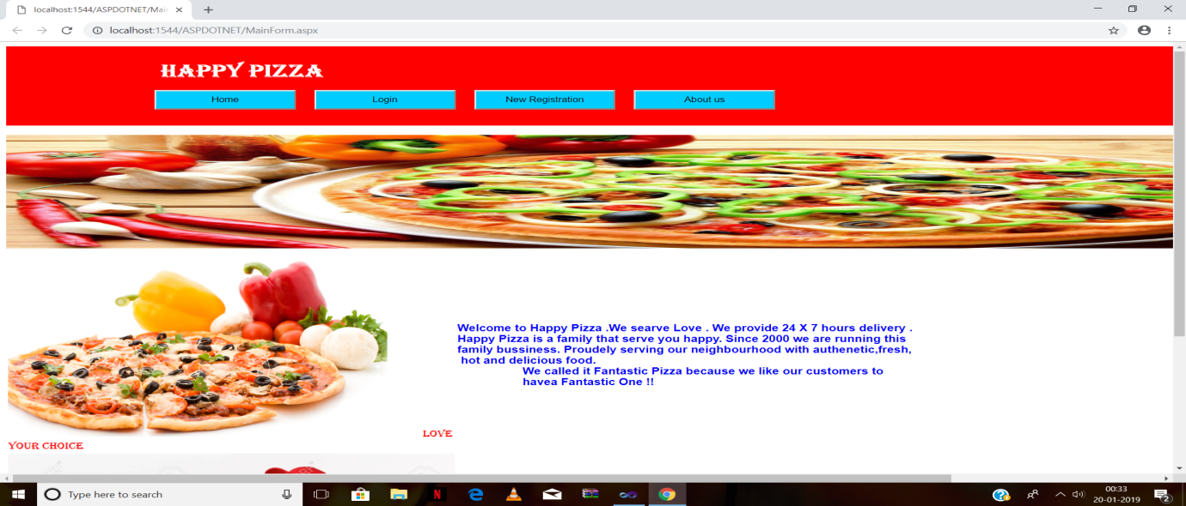

**Login Page**

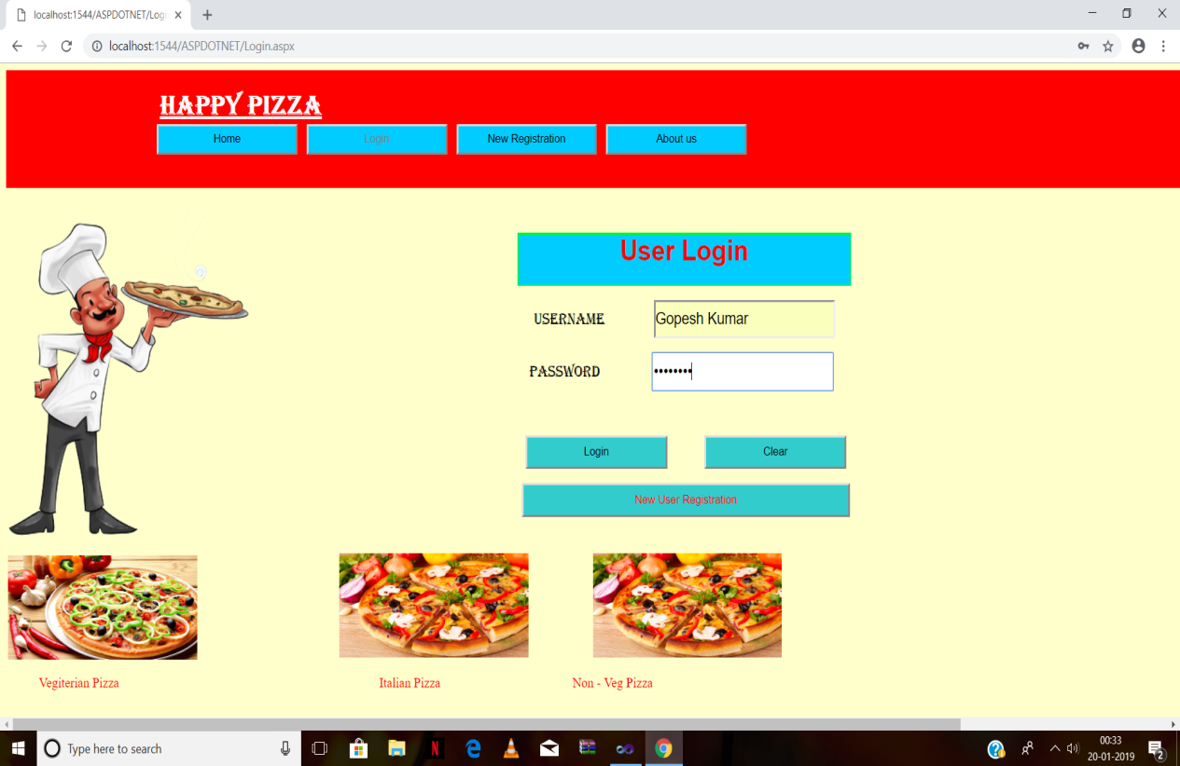

**New Registration**

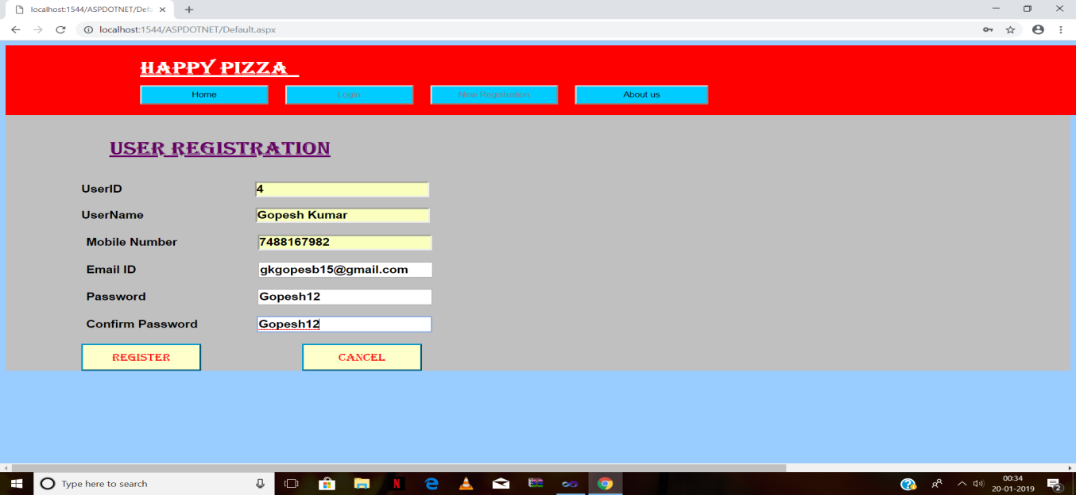

**Order Pizza**

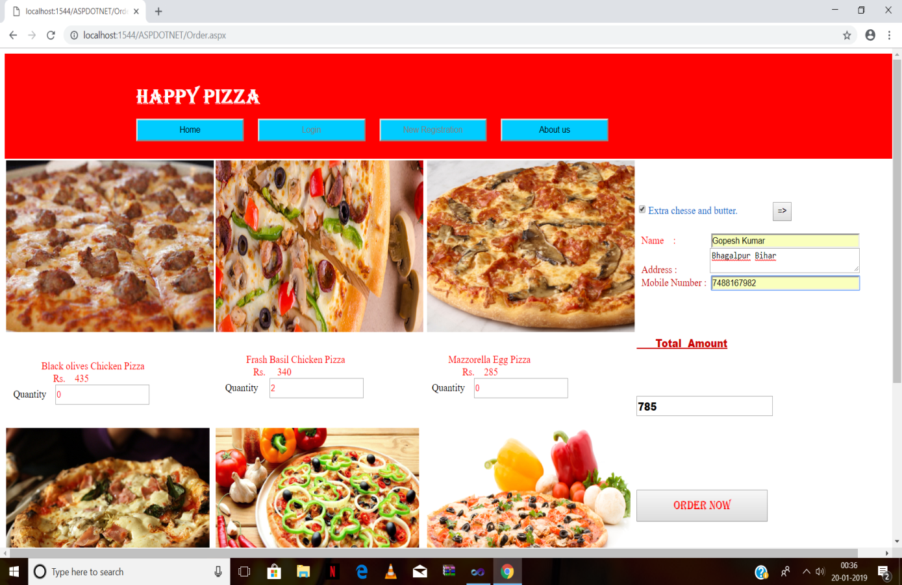

**Payments**

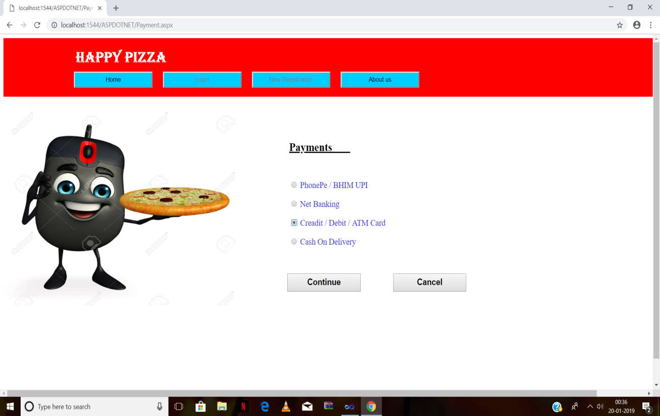

**PhonePe Payments**

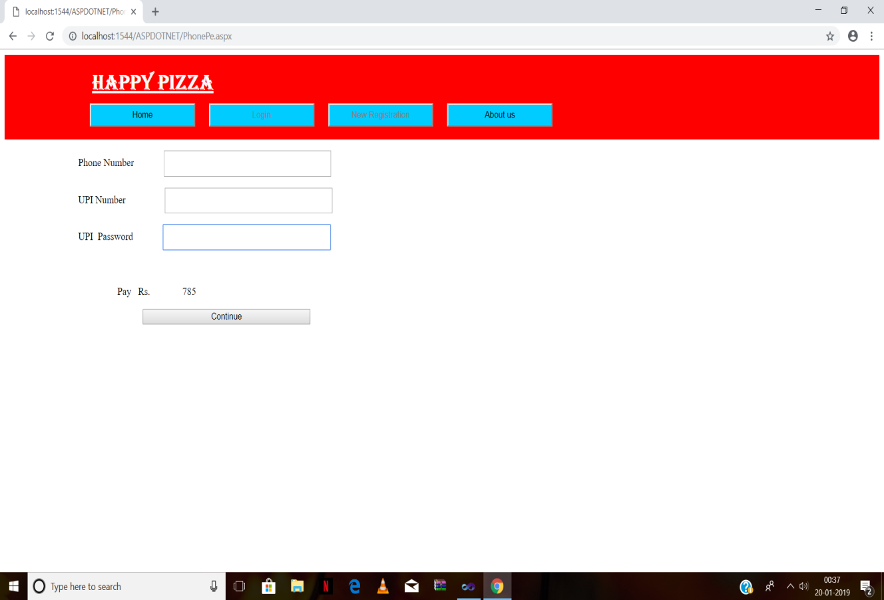

**Net Banking Payment**

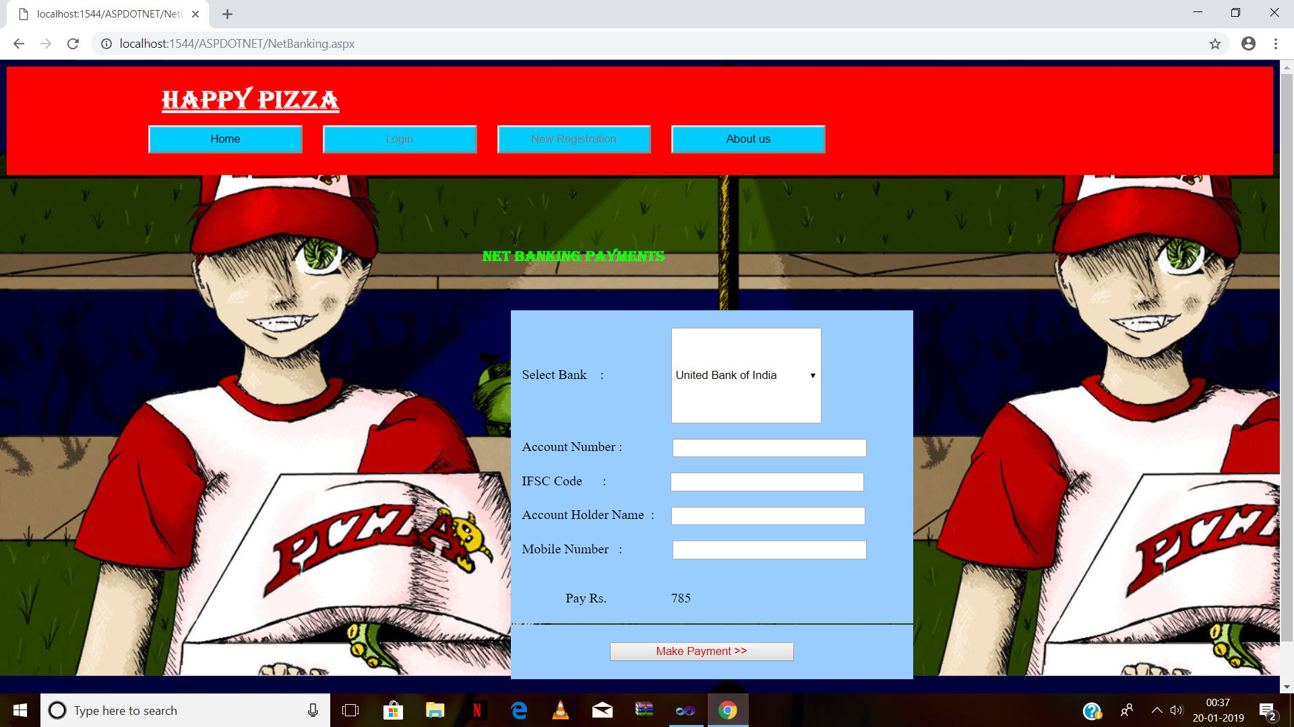

**Credit / Debit Card**

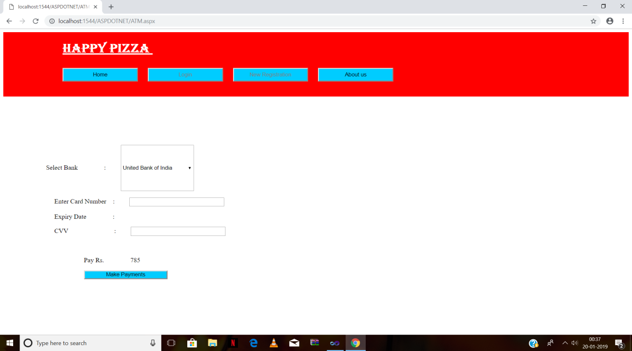

*The end*